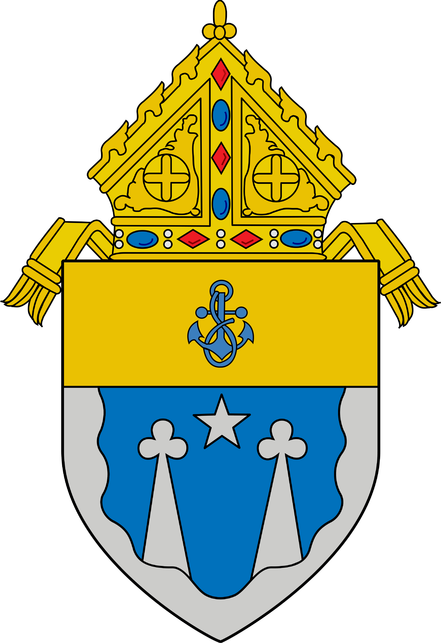
Tribunal of the Diocese of El Paso
Revised 1/2024

Questionnaire

PETITIONER
Name:
(maiden & married name)
Address:
City/State/Zip:
Phone: (H) (W)
Email Address:
Occupation:
Birth Date: City/Country:
Religion:
Baptism Date: Church:
Name of Parents:
Address:
RESPONDENT
Name:
(maiden & married name)
Address:
City/State/Zip:
Phone: (H) (W)
Email Address:
Occupation:
Birth Date: City/Country:
Religion:
Baptism Date: Church:
Name of Parents:
Address:
Information on Courtship and Marriage
Age at time of dating: (Pet.) (Resp.)
Age at time of engagement: (Pet.) (Resp.)
Length of courtship:
Age at time of marriage: (Pet.) (Resp.)
Church marriage date:
Church/City/State:
Civil marriage date:
City/State:
Length of married life: (Church) (Civil)
No. of separations:
Date of final separation:
Divorce Date:
City/State:
Who initiated the divorce?
No. of children: Who has custody?
Who pays child support?
Concerning Previous Marriages
Were you previously married? Yes No Please list the name(s) of previous spouse(s) and indicate whether it was civil or Church ceremony.
Concerning the Respondent
Was the Respondent previously married? Yes No Please list the name(s) of previous spouse(s) and indicate whether it was civil or Church ceremony.
What is the Respondent’s present name?
Please answer the following questions as thoroughly as possible. If you do not know the answer, please explain why.

YOUR PERSONAL AND FAMILY BACKGROUND
- DESCRIBE YOUR CHILDHOOD (i.e., where you grew up; no. of family members in the home; which persons influenced you while growing up).

- DESCRIBE YOUR TEEN YEARS (i.e., life at home; who disciplined; what were school years like; life at work if you held a job).

- WERE YOU ALLOWED TO DATE? AT WHAT AGE? GIVE DATING HISTORY.

- HOW WERE THE SUBJECTS OF DATING AND SEXUALITY TREATED IN THE FAMILY?

- DESCRIBE YOUR FAMILY (i.e., what were they like; what activities did you do as a family?).

- WHAT WERE SOME POSITIVE AND NEGATIVE EVENTS IN YOUR GROWING UP?

- WHAT DID YOU LIKE/DISLIKE ABOUT YOUR PARENTS?

- HOW DID YOU GET ALONG WITH YOUR BROTHERS AND SISTERS? HOW MANY WERE YOU? WHAT IS YOUR PLACE IN THE BIRTH LINE?

- HOW DID FAITH/RELIGION FIT INTO YOUR FAMILY? HOW WAS IT PRACTICED?

- WERE THERE ANY PROBLEMS WITH YOU OR YOUR FAMILY RELATED TO GAMBLING, PHYSICAL ABUSE, SEXUAL ABUSE OR MOLESTATION, DRUG OR ALCOHOL ABUSE? (If the answer is yes, please explain.)

- DESCRIBE YOUR ROLE IN THE FAMILY. HOW DID YOU HELP OUT IN YOUR HOME AS YOU WERE GROWING UP? WHAT GOALS DID YOU HAVE FOR YOURSELF?

- WHAT TYPE OF PERSON WOULD YOU DESCRIBE YOURSELF TO BE BEFORE THE WEDDING?

- WHAT TYPE OF PERSON WOULD YOU DESCRIBE YOURSELF TO BE AFTER THE WEDDING? WHAT TYPE OF PERSON ARE YOU NOW?

PERSONAL AND FAMILY BACKGROUND OF YOUR EX-SPOUSE.
- DESCRIBE WHAT YOU KNOW OF YOUR EX-SPOUSE’S CHILDHOOD (i.e., where they grew up; no. of family members in the home; which persons influenced him/her while growing up).

- DESCRIBE WHAT YOU KNOW OF YOUR EX-SPOUSE’S TEEN YEARS. (i.e., life at home; who disciplined; did they hold a job; what were his/her school years like)

- AT WHAT AGE WAS YOUR EX-SPOUSE ALLOWED TO DATE? GIVE THEIR DATING HISTORY.

- HOW WERE THE SUBJECTS OF DATING AND SEXUALITY TREATED IN THAT FAMILY?

- DESCRIBE YOUR EX-SPOUSE’S FAMILY (i.e., what were they like; what activities did they do as a family?).

- DESCRIBE SOME POSITIVE OR NEGATIVE EVENTS IN YOUR EX-SPOUSE’S LIFE WHILE GROWING UP.

- WHAT DID YOUR EX-SPOUSE LIKE/DISLIKE ABOUT HIS/HER PARENTS?

- HOW DID YOUR EX-SPOUSE GET ALONG WITH HIS/HER BROTHERS/SISTERS? HOW MANY WERE THERE? WHAT IS YOUR EX-SPOUSE’S PLACE IN THE BIRTH LINE?

- HOW DID FAITH/RELIGION FIT INTO HIS/HER FAMILY? WAS RELIGION PRACTICED IN THE HOME?

- WERE THERE ANY PROBLEMS WITH YOUR EX-SPOUSE OR HIS/HER FAMILY RELATED TO GAMBLING, PHYSICAL ABUSE, SEXUAL ABUSE OR MOLESTATION, DRUG OR ALCOHOL ABUSE? (If the answer is yes, please explain.)

- DESCRIBE YOUR EX-SPOUSE’S ROLE IN HIS/HER FAMILY. HOW DID YOUR EX-SPOUSE HELP OUT IN THE HOME AS HE/SHE WAS GROWING UP? WHAT GOALS DID HE/SHE HAVE FOR HIMSELF/HERSELF?

- WHAT TYPE OF PERSON WOULD YOU DESCRIBE YOUR EX-SPOUSE TO BE BEFORE THE WEDDING?

- WHAT TYPE OF PERSON WOULD YOU DESCRIBE YOUR EX-SPOUSE TO BE AFTER THE WEDDING? WHAT TYPE OF PERSON ARE THEY NOW?

COURTSHIP
- WHEN, WHERE, AND HOW DID YOU AND YOUR EX-SPOUSE MEET?

- WHEN ON A DATE, DID YOU GO ALONE OR WITH OTHERS? WHO WOULD GO WITH YOU?

- WHAT WERE YOUR ACTIVITIES DURING YOUR DATES?

- WHAT REACTION DID YOUR FAMILY AND HIS/HERS HAVE WHEN YOU STARTED DATING?

- WHAT REACTION DID YOUR FRIENDS HAVE WHEN YOU STARTED DATING?

- WHAT PROBLEMS EXISTED WHILE YOU TWO WERE DATING? (i.e., arguments, jealousies, abuses, etc.) PLEASE EXPLAIN.

- WAS THERE PRESSURE FOR SEXUAL ACTIVITY WHILE DATING EACH OTHER? HOW WAS IT RESOLVED?

- WERE THERE ANY BREAKUPS OR SEPARATIONS DURING THE COURTSHIP? PLEASE EXPLAIN.

- WHAT DID YOU LIKE /DISLIKE ABOUT YOUR EX-SPOUSE AT THE TIME OF DATING?

- DID EITHER OF YOU DATE ANYONE ELSE WHILE DATING EACH OTHER? PLEASE EXPLAIN.

- PRIOR TO MARRIAGE, WHAT DID YOU DISCUSS OR DECIDE ABOUT PERMANENCE / MARRYING FOR LIFE? WHAT WERE THE ATTITUDES OF EACH OF YOU TOWARD IT?

- PRIOR TO MARRIAGE, WHAT DID YOU DISCUSS OR DECIDE ABOUT MARITAL FIDELITY? WHAT WERE THE ATTITUDES OF EACH OF YOU TOWARD IT?

- PRIOR TO MARRIAGE, WHAT DID YOU DISCUSS OR DECIDE ABOUT YOUR INTENTION TO HAVE CHILDREN AND THE USE OF BIRTH CONTROL? WHAT WERE THE ATTITUDES OF EACH OF YOU TOWARD IT?

- PRIOR TO MARRIAGE, WHAT DID YOU DISCUSS OR DECIDE ABOUT DIVORCE? WHAT WERE THE ATTITUDES OF EACH OF YOU TOWARD IT? WAS THERE DIVORCE IN EITHER ONE OF YOUR FAMILIES OR FRIENDS? DID YOU CONSIDER THE POSSIBILITY OF DIVORCE IF THE MARRIAGE DID NOT WORK?

- PRIOR TO MARRIAGE, WHAT DID YOU DISCUSS OR DECIDE ABOUT PLANS FOR THE FUTURE, PERSONAL AND AS A FAMILY? WHAT WERE THE ATTITUDES OF EACH OF YOU TOWARD IT?

- PRIOR TO MARRIAGE, WHAT DID YOU DISCUSS OR DECIDE ABOUT PROFESSIONAL CAREERS (finishing studies, job, military duty, etc.)? WHAT WERE THE ATTITUDES OF EACH OF YOU TOWARD IT?

ENGAGEMENT
- HOW LONG BEFORE THE WEDDING DID YOU DECIDE TO MARRY IN THE CHURCH? WHO PROPOSED AND UNDER WHAT CIRCUMSTANCES? (i.e. pregnancy, moving, an ultimatum, etc.)

- IF THE DECISION TO MARRY WAS TO MARRY BY CIVIL COURT, BY A NON-CATHOLIC RITUAL, OR TO LIVE IN COHABITATION, PLEASE EXPLAIN WHY YOU DID THIS. (THE LAST SHEET OF THIS PACKET HAS MORE QUESTIONS REGARDING THIS TYPE OF SITUATION. PLEASE ANSWER THOSE QUESTIONS ALSO.)

- PLEASE DESCRIBE THE PRE-MARITAL PREPARATION YOU RECEIVED FROM THE PARISH CHURCH. (FOCCUS, Engaged Encounter, sponsor couple, meetings with priest, etc.)

MARRIED LIFE
- IN GENERAL, HOW WAS THE FIRST YEAR OF YOUR MARRIAGE? PLEASE EXPLAIN.

- WHEN DID YOU FIRST REALIZE THAT THERE EXISTED SERIOUS PROBLEMS? (Beginning, middle, last part of marriage) PLEASE EXPLAIN.

- SPECIFICALLY, WHAT WERE THOSE PROBLEMS?

- WERE THERE SIGNS OF THESE PROBLEMS BEFORE MARRIAGE? PLEASE EXPLAIN.

- WHAT DID YOU DO TO RESOLVE THESE PROBLEMS? WHAT WAS THE RESULT?

- WERE THESE PROBLEMS CAUSED BY ANY OUTSIDE INTERFERENCES (e.g., any other person)? IF THERE WERE, PLEASE EXPLAIN.

- WAS THERE ANY PARTICULAR GREAT DISLIKING BY EITHER ONE OF YOU TOWARD ANY ONE OF YOUR OWN OR THE OTHER’S FAMILY?

- HOW WELL DID YOU TALK THINGS OUT? WHAT COULD YOU NOT TALK ABOUT?

- DID YOU EXPERIENCE ANY TYPE OF PROBLEM IN YOUR SEXUAL INTIMACY? IF SO, WHAT KIND OF PROBLEM WAS IT?

- WHO MADE THE MAJOR DECISIONS, YOU OR YOUR EX-SPOUSE? GIVE EXAMPLES.

- WHAT TYPE OF SOCIAL LIFE DID YOU TWO HAVE? (i.e., together, separate, with friends, alone) PLEASE EXPLAIN.

- WERE YOU ABLE TO SHARE AFFECTION WITH EACH OTHER? PLEASE EXPLAIN (in public; only in private). WERE YOU EMBARRASSED BY THE SHOW OF AFFECTION?

- WAS THERE INFIDELITY IN YOUR MARRIAGE? IF SO, WHEN AND BY WHOM?

- WERE THERE ANY PROBLEMS RELATED TO DRUGS, ALCOHOL, VERBAL, PHYSICAL OR SEXUAL ABUSE? WHEN DID THEY BECOME EVIDENT? PLEASE EXPLAIN.

- WERE THERE ANY TEMPORARY SEPARATIONS IN THE MARRIAGE? (i.e. military service, job related, or because of arguments, etc.) PLEASE EXPLAIN.

- WERE CHILDREN BORN AS PLANNED? WAS BIRTH CONTROL PRACTICED? IF SO, AT WHOSE INITIATIVE? WHAT TYPE OF BIRTH CONTROL WAS USED?

- IF APPLICABLE, GIVE THE NAMES AND BIRTH DATES OF THE CHILDREN BORN OF THIS UNION.

- DID THE PREGNANCY AND BIRTH OF YOUR CHILDREN CHANGE YOUR MARITAL RELATIONSHIP? IF SO, PLEASE EXPLAIN.

- HOW DID YOU AND HOW DID YOUR EX-SPOUSE CARE FOR THE CHILDREN? (e.g., who bathed them, fed them, helped with homework, took them to the park, etc.) PLEASE GIVE EXAMPLES.

- DESCRIBE YOUR SHARING OF THE HOUSEHOLD CHORES AND MAINTENANCE.

- WHO SUPPORTED FINANCIALLY THE HOME AND FAMILY?

- HOW DID YOU LIVE YOUR RELIGIOUS FAITH IN THE HOME AND OUTSIDE THE HOME?

- DID THE MUTUAL LOVE AND RESPECT, INCREASE, DISAPPEAR, OR DID IT EVER EXIST?

- WHAT WERE THE MOST SERIOUS DISAGREEMENTS ABOUT? PLEASE EXPLAIN.

- WHAT WERE THE OPINIONS OF FAMILY AND FRIENDS REGARDING YOUR MARRIAGE BEFORE THE SEPARATION?

- AT WHAT POINT IN TIME DID YOU REALIZE THAT YOU HAD MADE A MISTAKE IN MARRYING?

- DID EITHER ONE OF YOU SEEK MARITAL COUNSELING? WHO DID? WHAT HAPPENED?

- WHO MENTIONED DIVORCE FIRST, WHO DECIDED TO FILE, AND WHO ACTUALLY FILED?

- WAS THERE ANY ATTEMPT AT RECONCILIATION BEFORE THE DIVORCE WAS FINALIZED?

CONCLUSION
- WHAT TYPE OF COMMUNICATION IS THERE BETWEEN YOU AND YOUR EX-SPOUSE TODAY?

- DO YOU WISH TO ADD ANYTHING ELSE?

OATH

DO YOU SWEAR BEFORE GOD AS YOUR WITNESS, THAT ALL STATEMENTS YOU HAVE MADE ON THESE PAGES ARE TRUE? YES

Signature of the Petitioner Date

CELEBRATION OF A CHURCH MARRIAGE AFTER MARRYING BY THE COURT

PLEASE ANSWER THE FOLLOWING QUESTIONS ONLY IF YOU MARRIED CIVILLY FIRST AND THEN BY THE CHURCH.
IF BOTH CEREMONIES OCCURRED IN MÉXICO WITHIN A TIMEFRAME OF LESS THAN SIX MONTHS, YOU DO NOT NEED TO ANSWER THESE QUESTIONS.

- Describe how the topic arose of getting married in the Catholic Church.

- What was your reaction to the idea of getting married in the Catholic Church?

- What was your ex-spouse’s reaction to the idea of getting married in the Catholic Church?

- Were there any pressures applied ON EACH OTHER or BY OTHER PERSONS to get married in the Church? PLEASE EXPLAIN.

- What was your motive in going through the Catholic ceremony after being married civilly? (e.g. solve problems, baptism sponsor, receiving God’s blessing, etc.)

- What was your ex-spouse’s motive, at the time, in going through the Catholic ceremony after being married civilly?

- Which problems in the marriage, if any, had already begun to appear before the Church ceremony?

- At the time of the Catholic ceremony, did either party already have serious doubts about whether the marriage would last or succeed? Please explain.

Signature of the Petitioner Date

